Weather Tracking application

Project Management Plan

Version 1.0.1

Jake Kidder, Yifei Yang, David Marten, Solomon Lin

TEAM 37

5/05/2016

Contents

Introduction and Purpose 2

Summary of Project 2

Assumptions 2

Client/Users 2

Deliverables 2

Scope 3

Approach/Methodology 3

Timelines 3

Personnel/HR management 4

Communications management 4

# Introduction and Purpose

Our team has created a weather tracking app that allows users to search the weather information from multiple locations around the world. The main goal of the application was to provide an easily accessible service to many different types of users. The app allows the user to search and save any location to their favourites and then find out information such as temperature, humidity and wind speed.

This document outlines a summary of the project as well as the process that was taken in order to complete the application. It also summaries what tools and services were used in order for the team to communicate with one another, and a list of targets and deadlines that were followed in order to ensure that the team was on track in completing this project,

# Summary of Project

## **Assumptions**

This weather app is mostly based on the forecast.io API, all the weather information is sent back from this website. Without this API website, the app cannot receive weather information. The other important API is from Google Map API, it provides users the precise locations they searched. The app will not be supposed to work properly without the two APIs.

## **Client/Users**

Since the weather keeps changing, the expected users are those who need to go outside and own an iPhone device. With this weather tracking app, users are able to receive current weather information of a particular location which is convenient. In the other hand, for this project, some authorised weather forecast company such as Bureau of Meteorology will be the stakeholders. Some of the radio channels and weather forecast television news will profit from this weather tracking app project as well.

## **Deliverables**

As a weather tracking app, the purpose of the app is to track the current weather information of a particular location with Google Map displayed on the screen. The app is able to find any location that the user wanted and save that location with a nickname for convenience. It could also remove any locations that the user no longer has interest to know about the weather information. The app is able to provide weather information over past 30 days so that the user could have a better analysis of the weather for that location. The app provides a brief summary, minimum temperature, maximum temperature, humidity and wind speed as well as the date for the location which users wanted to know.

# Scope

## Approach/Methodology

The project will be broken up into multiple individual parts, for example, functions to find the location the user input, the save location button and add the desired location to the main page list etc. In particular, each task of the app will be dealt with one at a time as a team. For instance, some of the team members, if not all due to different commitments, will gather together regularly to write the code of the app. Due to the limitation of the system, group members cannot edit the code at the same time, so it is imperative for members to commit it to the repository in Github after they have made progressive changes individually. It is done in order to allow other team members to have access to the most updated version of the code. The benefit of this limitation actually produces a better written code where everyone comes together and contributes their thoughts and ideas on the code. It will be too difficult for an individual to complete that task alone.

Furthermore, the communication of the project, as to set up meeting time and trouble shooting of the code, will be done through Asana instead of through social media Facebook. The reason for that is because in this way, it would be much more manageable and systematic with respect to keeping track of all past conversations and to allocate tasks to different group member. Additionally, the google drive will be used to share documents such as, presentation slides and user guide documents in order to provide a more manageable space where all the group members have easy access to.

*Describe briefly how this project will be handled at a high level*

## Timelines

The millstones of the project are tabulated below along with the target completion date. Since the tasks are closely related to one another, some task will have to be complete prior to some other task. The dependencies of the tasks are also depicted in the figure below.

Table 1. Milestones of the project and target completion date

|  |  |
| --- | --- |
| Milestones | Target completion date |
| Add location page (html, js) | 28/05/16 |
| View location page (html, js) | 28/05/16 |
| Main page (html, js) | 28/05/16 |
| Locationweathercache (js) | 28/05/16 |
| Project Management Plan | 28/05/16 |
| User Guide | 28/05/16 |
| Presentation slides | 26/05/16 |

Figure 1. Dependencies of the milestones

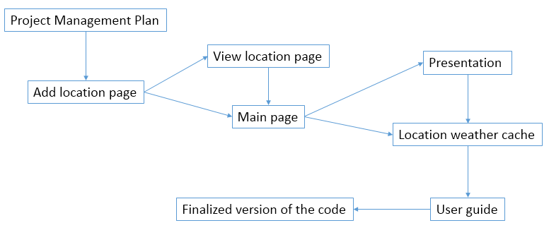

First of all, the project management plan will need to be carried out prior to the start of the coding tasks. The “Add location page” will need to be done first because the app will need to use the desired location to achieve the weather information. However, due to the limited time and skills, the code for location weather cache will possibly not be able to have completed before the presentation on the 26th May. As a result, the presentation will provide a progressive summary as to what the team has done so far. After the presentation, the user guide and the finalized version of the code will be expected to finish before deadline (29th May).

As previously mentioned, the tools that will be utilized will include communicating through asana, committing the code to Github and sharing documents on Google Drive. Also, the team will be split further into 2 pairs as every member has different class timetable and commitment. The pair will gather together and work on the code. After that, the progress will be communicated to the unattended. This strategy aims to finish the required task in a more efficient and effective way in order to minimize time and avoid overlapping work.

# Personnel/HR management

Our team consisted of:

* Solomon Lin – [tklin2@student.monash.edu](mailto:tklin2@student.monash.edu)
* David Marben – [dmar64@student.monash.edu](mailto:dmar64@student.monash.edu)
* Yifei Yang – [yyan548@student.monash.edu](mailto:yyan548@student.monash.edu)
* Jake Kidder - jkid

Roles and responsibilities were assigned to each team member through task allegation in Asana. Each team member was responsible for completing a certain part of the assignment by a deadline, such as completing coding tasks or working on written documentation. Deadlines were given to ensure that the work was organised and the project was able to progress during completion. Tasks were always facilitated in group meetings and through Facebook messenger. Team members also had the responsibility to ask other members for assistance if they were unable to complete a certain task for any reason (e.g. lacking skills, not understanding). David and Ain were responsible for various sections of the “locationWeatherCache” script, while Jake and Solomon worked on the “addLocationPage”, “mainPage”, and “viewLocationPage” files. Every group member was responsible for the written documentation, which was left until after the Project was complete.

# Communications management

Asana was the primary source of communication for the group, followed by Facebook. Team members were able to create topics and discussion points which were accessible by everyone and members were also notified of this via emails from Asana. The main point of the discussions on Asana were directly related to the specific tasks for the project, such as what needed to be completed by who, and by which deadline. These points were further discussed in person when team meetings were held. Facebook was used to discuss general information concerning the project. Facebook was also a great way to organise team meetings regularly. The team would simply organise a time that suited everyone to meet up a given location, usually the computer labs, and a team member was able to notify everyone if they were running late or unable to attend.